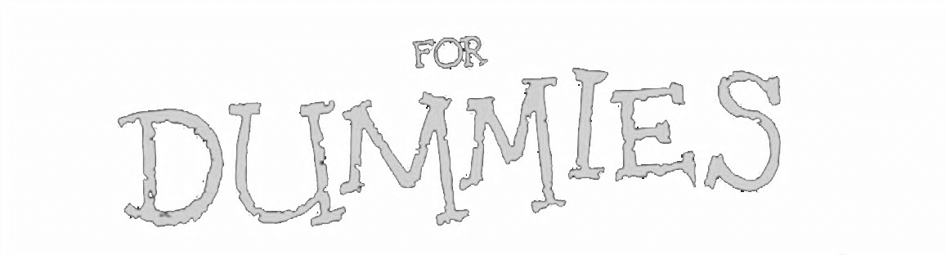
MLA Citations
Mrs. Greenwood Style

So what’s the big deal about citing sources anyway?
If you do not cite sources you are stealing someone else’s work or ideas.
Now that might not sound like a big deal, but to schools and teachers, it is, and if you are caught stealing someone’s ideas or work it’s called plagiarism. If you are caught plagiarizing a document then you will be punished, with punishments ranging your instructor asking you to redo your assignment to being kicked out of school. Yes, you read correctly, Universities can and will kick out students who plagiarize.

When do I have to cite my information?
If in doubt, cite it! If you are not sure whether you should cite a passage or concept, do it. Unless something is accepted as common knowledge like “Columbus sailed in 1492,” then it is generally a safe idea to simply add a citation. If you quote something word for word from a source, it is called a quotation. If you “put it in your own words” then you have created a paraphrase. Even paraphrases must be cited.

Where to cite?
In MLA (the citation method created by the Modern Language Association—aka the “English Gods”—and the method used in most English courses), you will cite your sources in TWO places. First, you create a parenthetical citation in the body of your paper, at the end of the sentence where your quoted/paraphrased material appears. This is also known as an in-text citation. Second, you will create a bibliography page that contains more detailed information about the source you cited in your paper. (Your final page of citations can go by various names, depending on what you choose to put on them. Works Cited and Bibliography are not the same. In Works Cited you only list items you have actually cited. In a Bibliography you list all of the material you have consulted in preparing your essay whether or not you have actually cited the work. Their formatting, however, is exactly the same.)

How to cite?
Because you have to cite your source both in-text and in a bibliography page, this has been broken down into two sections: Bibliography Pages and Parenthetical/In-text Citations

Bibliography Pages

In order to create a proper Bibliography Page, you need to know several things:
- The creation of a bibliography page involves absolutely no critical thinking beyond figuring out what kind of source you are citing. This is as mathematical as English stuff gets—it’s “plug and chug.”
- Your bibliography page should NEVER be created as a document separate from the paper that you are writing. If you do this, you will inevitably forget to print off the bibliography page and attach it to your paper, resulting in a ZERO on the assignment because it will be considered plagiarism.
- I highly recommend that you create your bibliography page as you write your paper. Because the bibliography page and the parenthetical citations work hand in hand, it is much easier to cite things properly as you go rather than attempting to “go back and do it later.” Just ask my husband about this…

Page Formatting
A bibliography page must be formatted in a very specific manner. In general, your bibliography page:
- Begins on a separate page at the end of your paper. It should have the same one-inch margins as the rest of your paper.
- Label the page Bibliography (do not italicize the word Bibliography or put it in quotation marks), and center the word Bibliography at the top of the page.
- Double space all citations, but do not skip spaces between entries.
- Indent the second and subsequent lines of citations five spaces so that you create a hanging indent.
- For every entry, you must determine the Medium of Publication. Most entries will likely be listed as Print or Web sources, but other possibilities may include Film, CD-ROM, or DVD.
- Writers are no longer required to provide URLs for Web entries. However, if your instructor or publisher insists on them, include them in angle brackets after the entry and end with a period. For long URLs, break lines only at slashes.
- Entries must be listed in alphabetical order, based on what comes first in the entry. (Typically, this is the author’s last name.

Entry Formatting
Technology is a wonderful thing. Feel free to use an online citation machine to help you format your individual bibliographic entries. HOWEVER, you are responsible for double-checking the correctness of the citation machine.

Citation Machine: Son of Citation Machine
- http://citationmachine.net/
- Be sure to choose the MLA option!

Double-Checking the Citation Machine’s Work/Doing it By Hand
- Purdue OWL at http://owl.english.purdue.edu/owl/
- On the bottom left, find the “Suggested Resources” list and click on the link for the “MLA Guide.”

Parenthetical/In-Text Citations

In order to create a proper in-text citation, you need to know several things:
- How the Bibliography page entry looks for this particular source.
- Page number on which the quotation appeared.

Entry Formatting
Typically, parenthetical/in-text citations are pretty straightforward. They appear in parenthesis at the end of the sentence that includes a quotation or at the end of a paragraph that includes paraphrased information. There are typically two ways to do them. The author’s name may appear either in the sentence itself or in parentheses following the quotation or paraphrase, but the page number(s) should always appear in the parentheses, not in the text of your sentence. For example:

Wordsworth stated that Romantic poetry was marked by a "spontaneous overflow of powerful feelings" (263).

Romantic poetry is characterized by the "spontaneous overflow of powerful feelings" (Wordsworth 263).

Wordsworth extensively explored the role of emotion in the creative process (263).

When a source has no known author, use a shortened version of whatever appears first in the bibliographic entry for this particular source. This will be formatted in the same manner as on the bibliography page. You will still need to provide a page number.

We see so many global warming hotspots in North America likely because this region has "more readily accessible climatic data and more comprehensive programs to monitor and study environmental change . . ." ("Impact of Global Warming" 6).

For this source, the bibliography entry appears on the bibliography page as follows:

"The Impact of Global Warming in North America." Global Warming: Early Signs. 1999. Web. 23 Mar. 2009.

